**Hot Water Carpet Extraction Machines.**

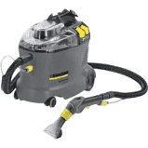**Kärcher Spray Extraction Cleaner Puzzi 8/1 C £394.80 Net**

**Professional quality cleaner**

The powerful and compact Puzzi 8/1 C enhances Kärchers spray extraction range as it is ideal for upholstery cleaning and spot cleaning of carpeted floors.

Due to the excellent suction power, the Puzzi 8/1 C leaves carpets and upholstery virtually dry to touch in minutes. Its lightweight construction means this unit can be transported easily from one place to another perfect for use in hotels, hospitals, shops and the automotive.

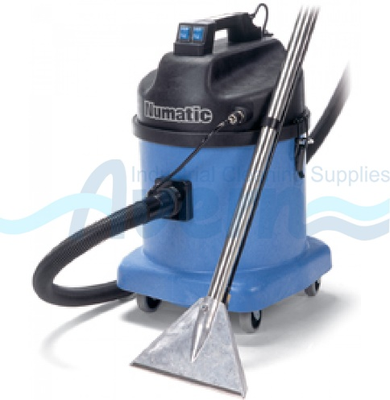**CTD570 Industrial Carpet & Upholstery Cleaner – Numatic £670.80 Net**

The Numatic CTD570 features an entirely StructoFoam drum and head design, making it very tough and ideal for industrial and commercial mobile cleaning solutions. Its compact size also makes it ideal for spot cleaning within nursing homes and hotels. The tank within a tank construction of this machine means the solution tank is housed within the outer drum, keeping the profile of this machine as small as possible without compromise on capacity.

Dual motors on this model offer superior levels of suction, ensuring any cleaned fabrics and upholstery are left as dry as possible, ready traffic sooner than other models.

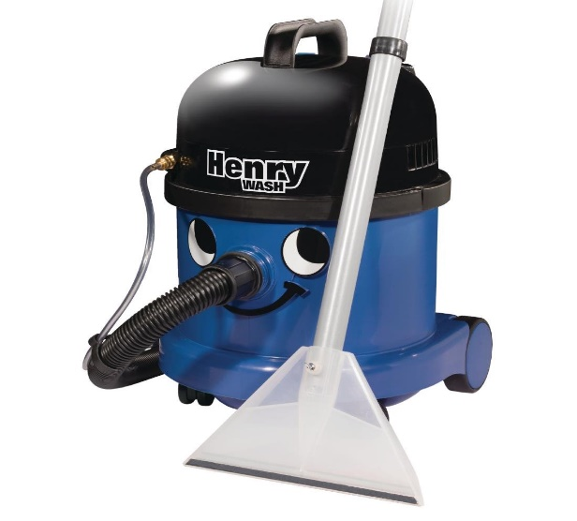  **Henry Wash Carpet and Upholstery Cleaner £235.18 Net**

The Henry Wash is a versatile carpet, floor and upholstery cleaner with a long 10m cable for a bigger range and 5 litre water capacity, making it suitable for tackling a wide variety of tasks. Able to restore carpets, clean hard floors, valet cars, suck up spills and unblock sinks the Wash can do the work of several machines in one. Thanks to a full wash kit, 1060W motor and rotating brush bar that lifts stubborn dirt and grime, this powerful machine makes cleaning carpets as simple as vacuuming.

Henry Wash pumps water and detergent into a diffuser, for even distribution and complete coverage. This ensures floors and carpets are washed and dried thoroughly, leaving them hygienic, dry to the touch and smelling fresh. The shampoo hand tool is also ideal for giving soft furnishings, car seats and carpets a deep clean, leaving them revived and refreshed with a minimum of effort. As with the original Henry, a full range of accessories is included to suit various tasks.

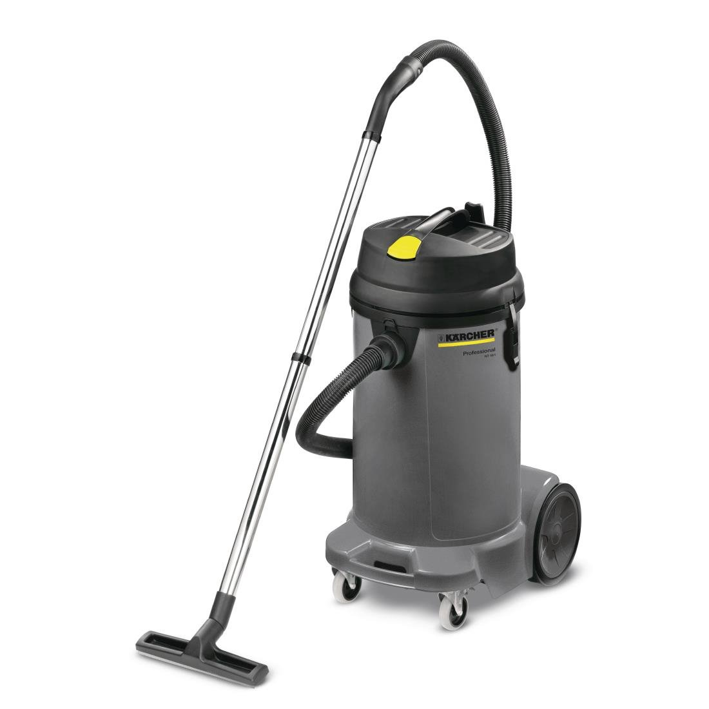**Kärcher Wet and Dry Vacuum £234.99 Net**

The Kärcher wet and dry vacuum is a professional vacuum cleaner, suitable for wet or dry debris such as kitchen spills. This powerful vacuum cleaner features a generous 48 litre capacity and automatic shut off when full, making this a practical and easy-to-use vacuum cleaner. All the attachments are stored on the machine itself, saving you space and making them easily accessible when you need to clean different areas.

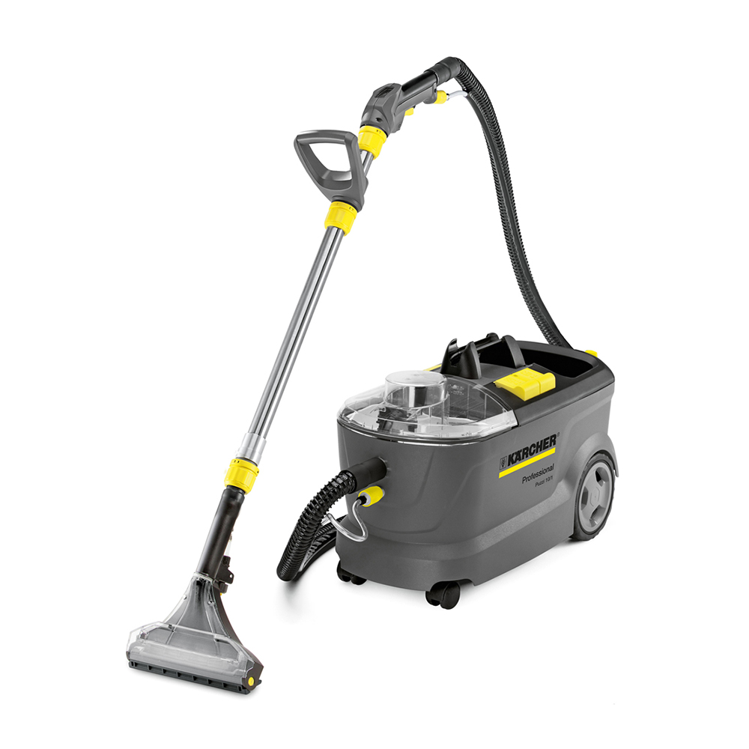**Kärcher Puzzi 10/1 Extraction Cleaner £527.99 Net**

The **Puzzi 10/1** is a powerful spray extraction machine designed for easy, efficient deep cleaning of carpets, upholstery and textile flooring. The **Puzzi 10/1** is an exceptional all-rounder, with added features which makes using the machine even quicker and easier. This makes it a favourite amongst car dealers for valeting the interiors of new and used vehicles.

With a powerful 1 bar spray rate, the water and detergent solution is applied to the area being cleaned and picked up immediately by the vacuum nozzle. The cleaned surface can be walked on almost straight away as very little residual moisture remains.

Carpets dry up to 63% faster than those cleaned with other comparable products.

**[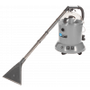](https://www.janitorialdirect.co.uk/media/product/783/cleanfix-system-7-carpet-cleaner-tw300s-fa4.png)Cleanfix System 7 Carpet Cleaner TW300S £466.19 Net**

The Cleanfix System 7 (TW300S) is a deceptively robust and highly effective carpet and upholstery cleaner, it is largely used in nursing homes, hospitals and hotels, but can equally lend itself to many other applications. The Cleanfix System 7 is so light that it ensures ease of use for all operators.

This highly popular carpet and upholstery cleaner is also used in the hire market because of its durability and the instructions on its side.

The Cleanfix System 7s light and robust nature means that we often sell the System 7 to nursing homes to deal with residents who suffer from incontinence and spillages. However, we have also sold these machines to domestic users who have a need for regular cleaning. The Cleanfix System 7 is therefore an all-round solution to any carpet or upholstery cleaning needs, commercial or domestic.